**Bone Fracture Detection**

**Team Members:**

1. **Omnia Saaed 20228003**
2. **Amira Kamel 20228004**
3. **Roaa Ahmed 20228006**
4. **Farah Ashraf 20228015**
5. **Menna Osama 20228020**

**Supervised By:**

**Dr: Soha Ahmed**

**Dr: Ahmed Swar**

**Overview**

To build and evaluate machine learning and deep learning models for automatically classifying X-ray images into **fractured** and **not fractured** categories.

**Source**: Kaggle Datasets

**Dataset Preparation**

* **Source**: X-ray image folders categorized as:
  + train/fractured-labeled
  + train/not fractured-labeled
  + test/fractured-labeled
  + test/not fractured-labeled

**EDA**

* + 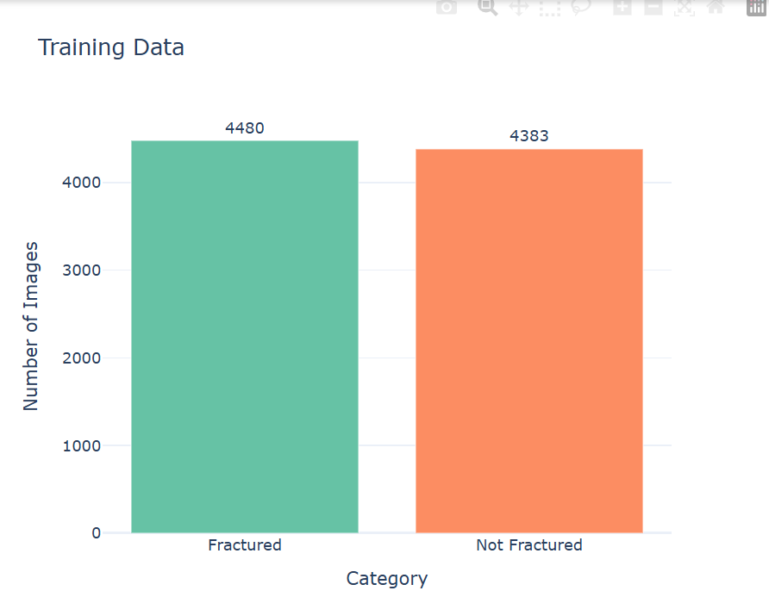Show Distribution of the data

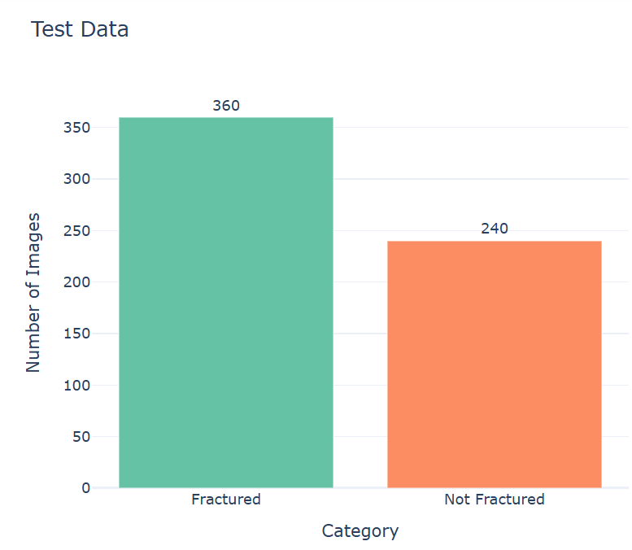

* + Check for corrupted/invalid Images
  + Check for duplicated Images
  + 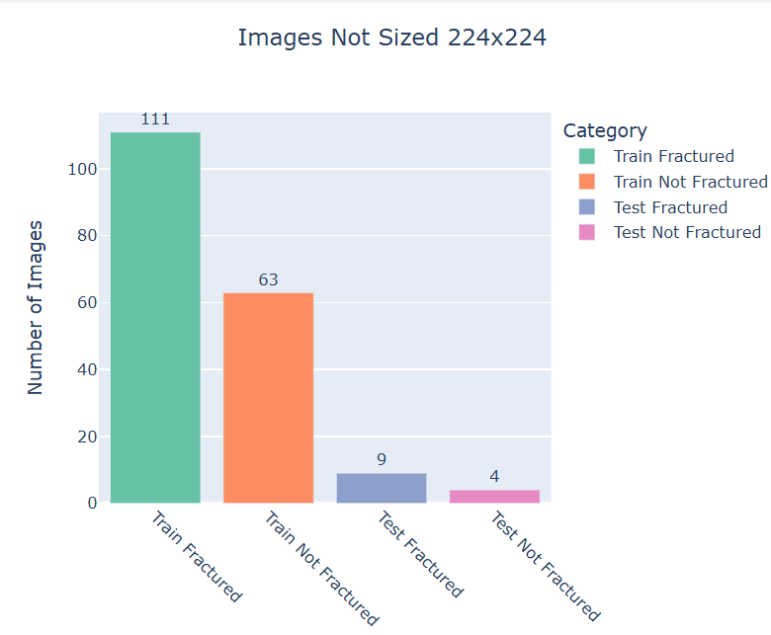Check for images size
  + Check For quality of images

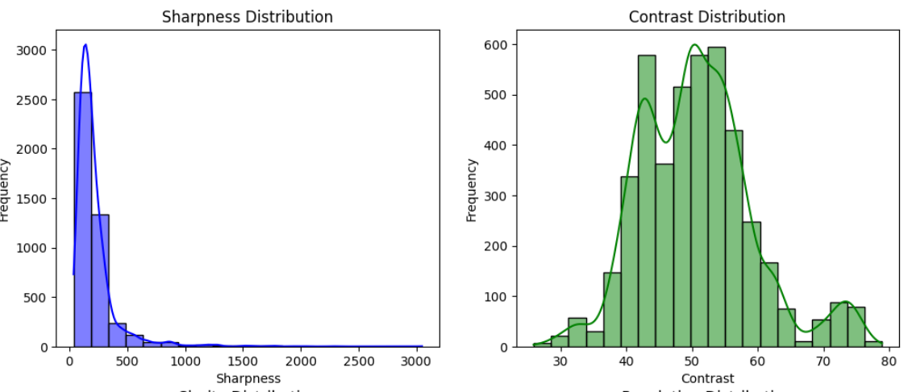

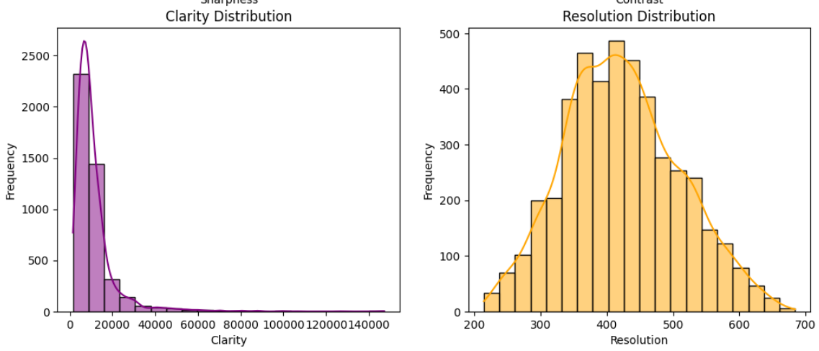

**Preprocessing**

* + Resize Images to ‘ 224*224 ’
  + Enhance The Image quality by
    - Enhance The Contrast
    - Remove noises using GaussianBlur
  + Extracted relative paths for labeling.
  + Created CSV files with image paths and binary labels (1 = fractured, 0 = not fractured).
  + Combined and shuffled data into train_df and test_df.

**Classical ML**

* Used **MobileNetV2** as a feature extractor (without the top classification layer).
* Extracted features and trained:
  + **1)** **Logistic Regression**
    - Accuracy: ~67%
    - Confusion Matrix

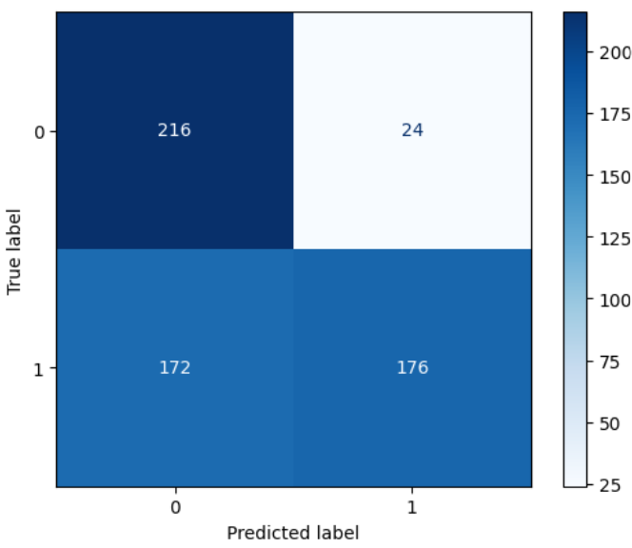

* + - 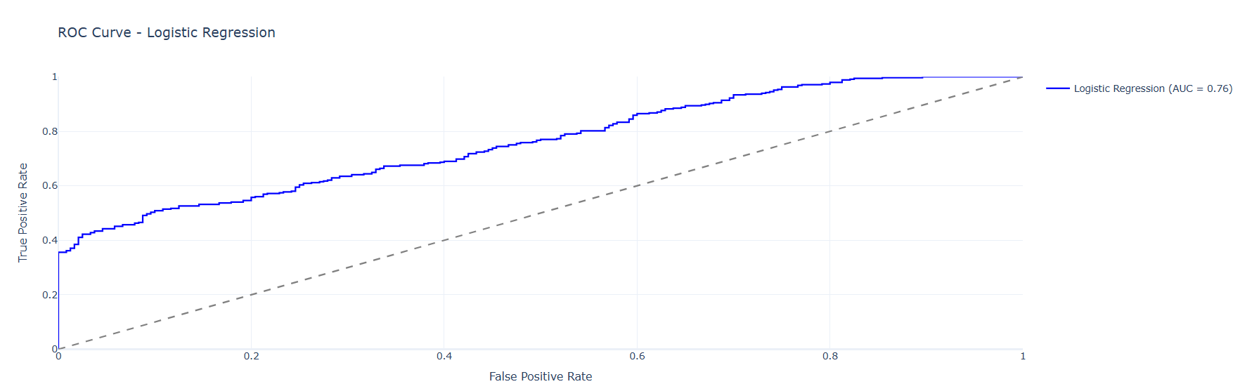ROC and loss curves visualized.

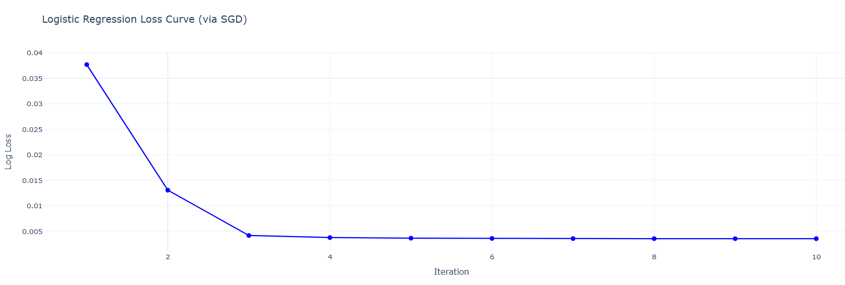

* + **2)** **KMeans Clustering**
    - Evaluated as an unsupervised baseline.
    - Accuracy: ~49% (as expected from unsupervised learning).
    - Confusion Matrix

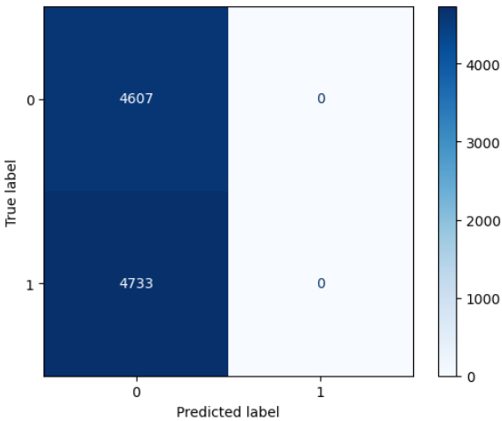

* + - Plotted inertia curve (Elbow Method) and ROC.

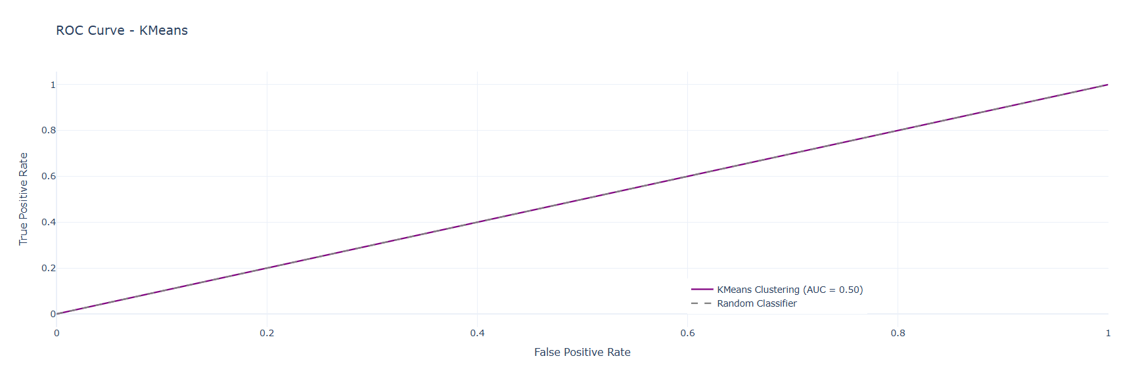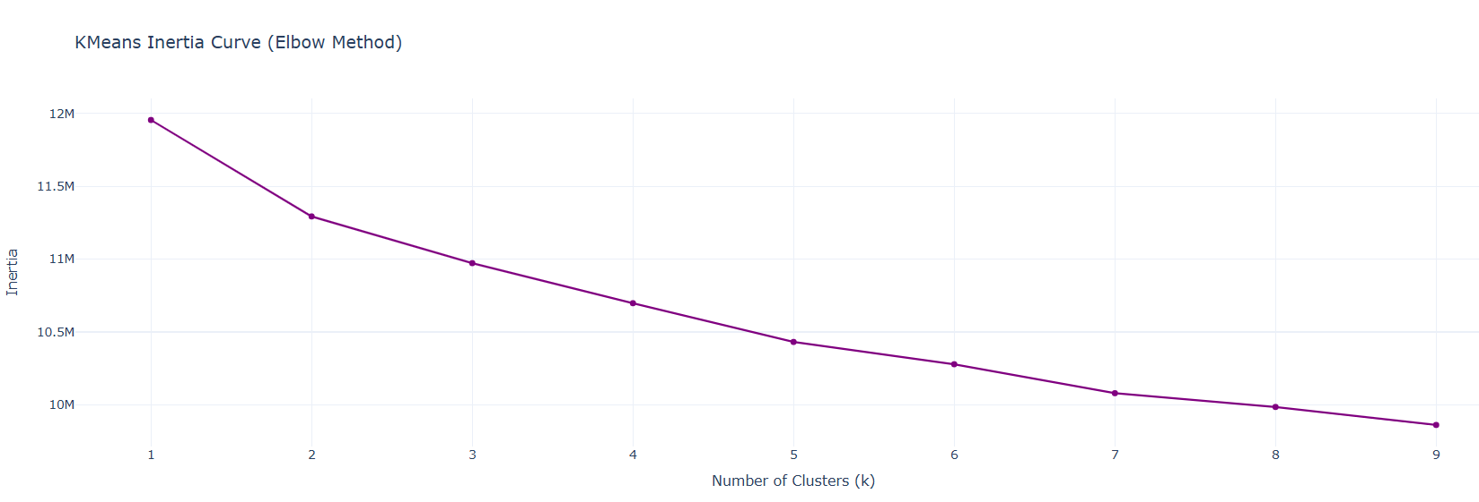

**3. Deep Learning CNN Model (Custom)**

* Built a custom CNN with:
  + Conv2D, MaxPooling, GlobalAveragePooling, Dense, and Dropout.
* Trained with early stopping on accuracy.
* Evaluation:
  + Accuracy on test set plotted. ~76%
  + Confusion matrix

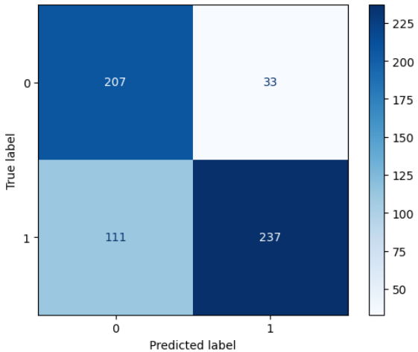

* + 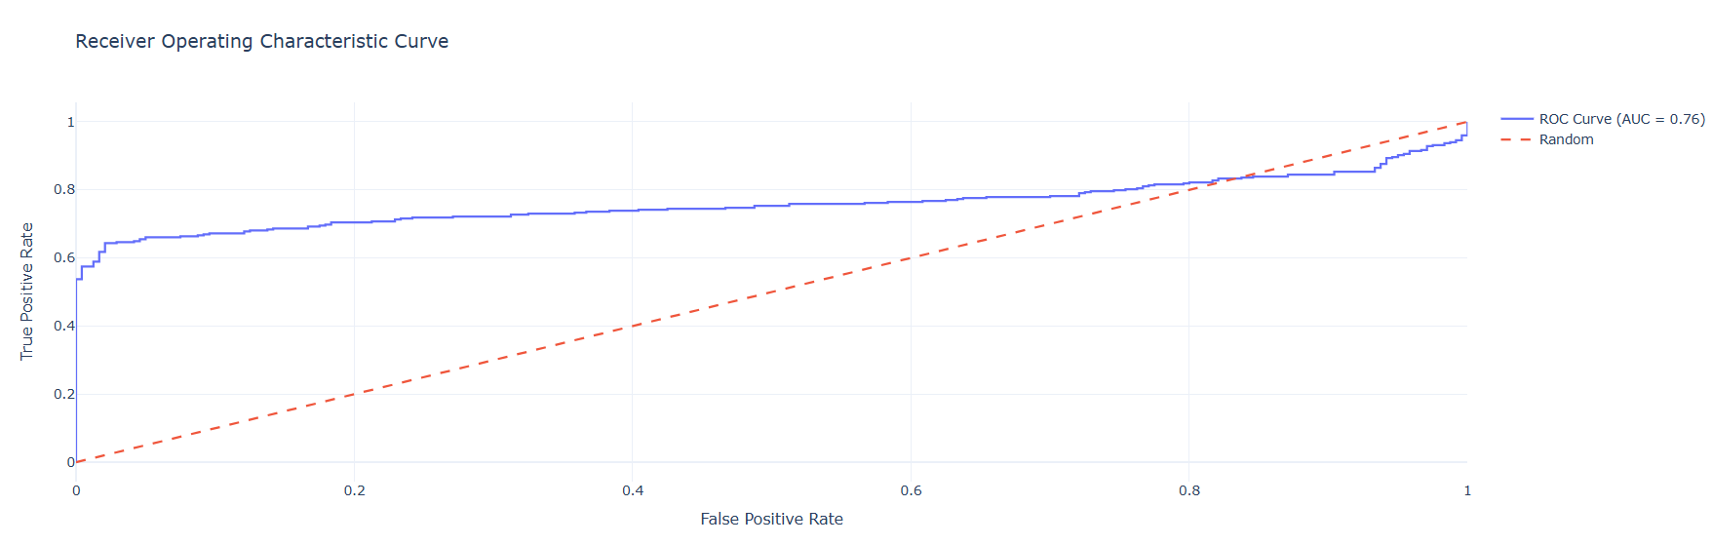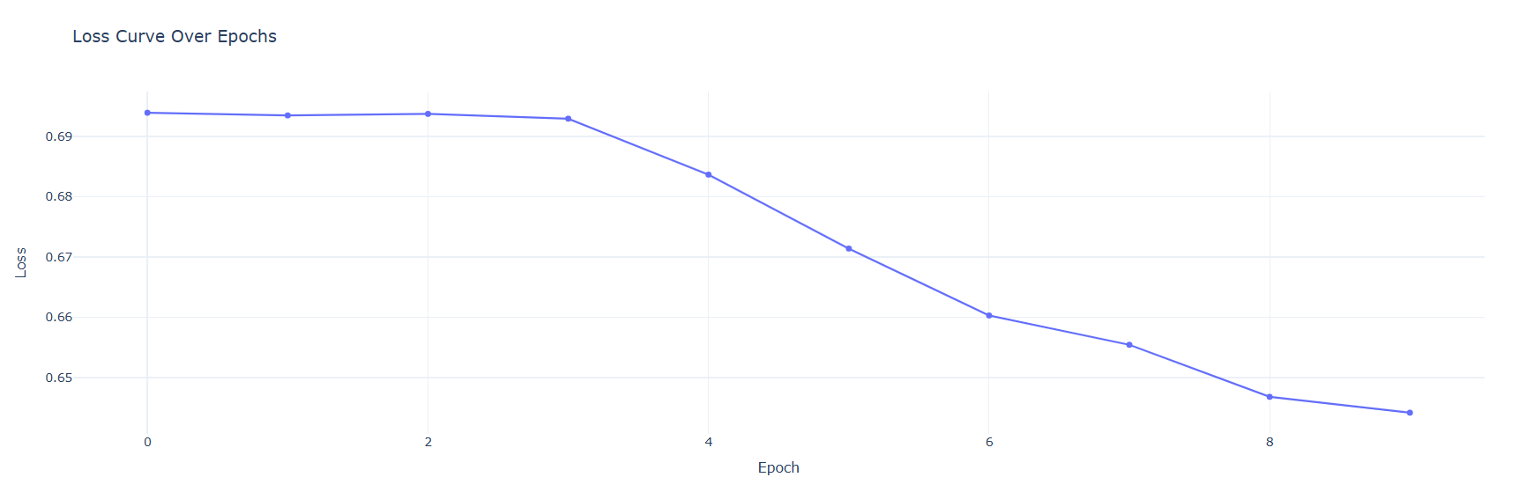 ROC curve, and loss curves visualized.

**4. Transfer Learning (ResNet50)**

* Used **ResNet50 (pretrained on ImageNet)** as a frozen feature extractor.
* Added custom classification head.
* Trained and evaluated on the same X-ray dataset.
* Results included classification report and accuracy. ~59%
* ROC curve, and loss curves visualized.

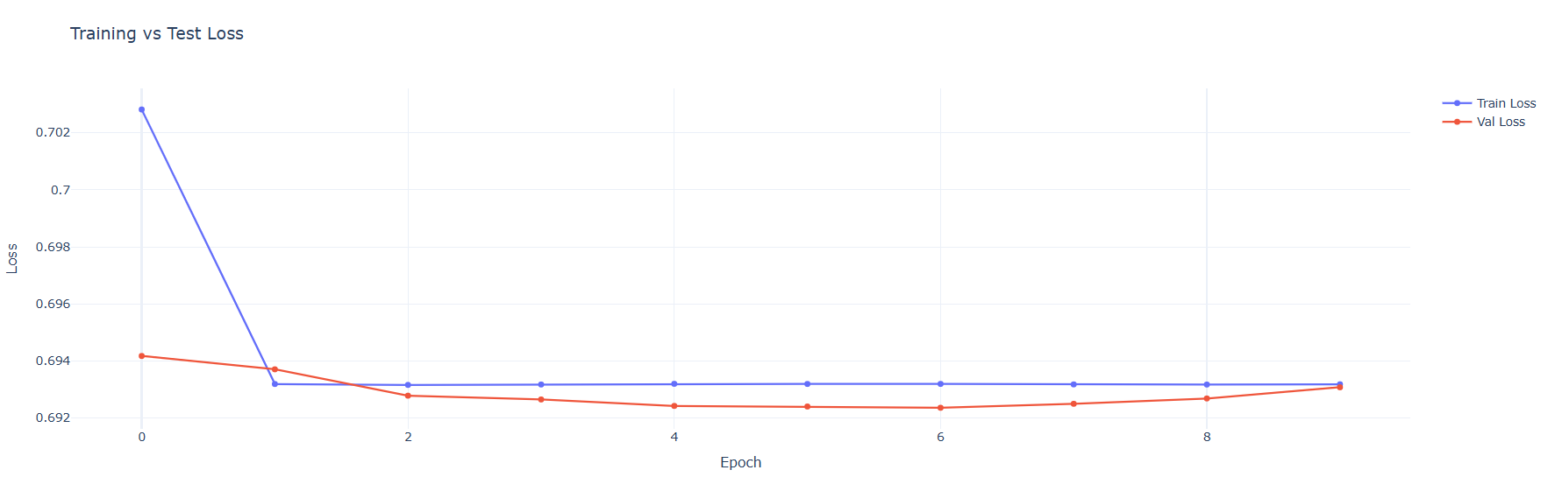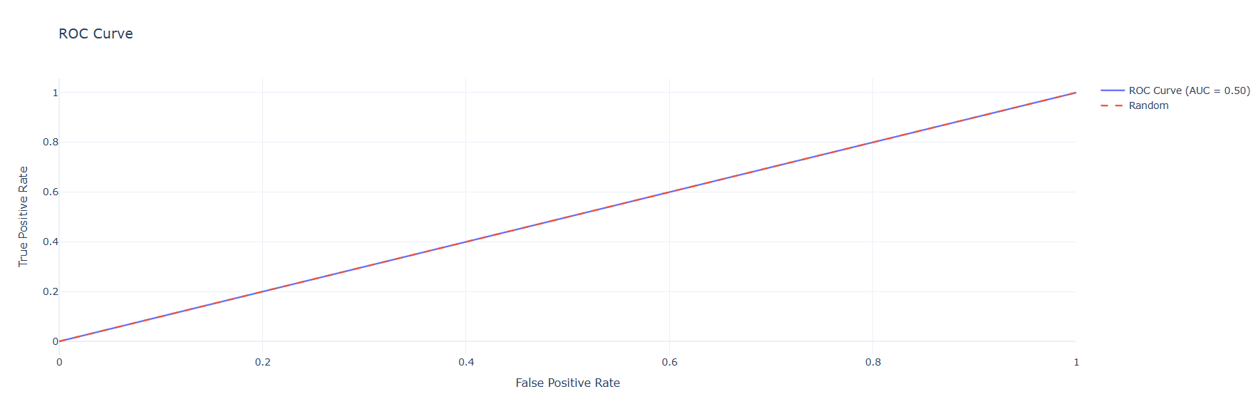

|  |  |  |  |
| --- | --- | --- | --- |
| **Model** | **Accuracy** | **AUC (ROC)** | **Notes** |
| Logistic Regression | ~0.67 | ~0.70 | Classical ML with deep features |
| KMeans Clustering | ~0.49 | ~0.50 | Unsupervised baseline |
| Custom CNN | ~0.75+ | ~0.80 | End-to-end image learning |
| ResNet50 Transfer | TBD | TBD | Powerful pretrained backbone |

**📈 Key Metrics (Sample Summary)**

**Conclusion**

This project showcases a full **machine learning pipeline**:

* Data labeling & preprocessing
* Deep feature extraction & classical modeling
* Custom deep learning modeling
* Transfer learning with state-of-the-art architectures
* Evaluation using both **metrics** and **visualizations**